

**Provisioning Template for Delete Wide IP**

**User Guide**

|  |  |  |
| --- | --- | --- |
| **Version** | **Remarks** | **Date** |
| **1.0** | **Provisioning Template User Guide for Delete Wide IP** | **01/08/2016** |
| **2.0** | **Updated document with installation of the template.** | **14/02/2017** |
|  |  |  |
|  |  |  |

## Installation of the Template and Helper Script

1. Login to AppViewX.
2. On the left navigation menu, select ***Provisioning***; and click ***Template.***
3. On the upper right portion of the screen click on the  Import button.
4. The following screen will appear. 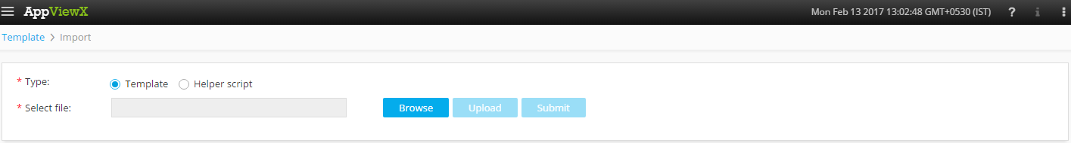
5. Please Select Template/Helper Script.  
   If Template is chosen,
   1. Click on *Browse* and select the Zip File of the template which has to be installed/imported and click open.
   2. Click on upload to import the Zip file and display the templates present in the zip file.
   3. Click on submit to deploy the templates into the AppViewX Environment.

If Helper Script is chosen,

1. Click on *Browse* and select the Zip File of the Helper script which has to be installed/imported and click open.
2. Click on upload to import the Zip file and display the Helper Scripts present in the zip file.
3. Click on submit to deploy the Helper Scripts into the AppViewX Environment.

## Delete Wide IP Template

1. Login to AppViewX.
2. On the left navigation menu, select ***Provisioning***; and click ***Request***
3. On the upper right portion of the screen, click the  ***Create*** button.
4. Select the provisioning template name from the list – ‘**Generic Delete Wide IP’**

**Note:** *If no template is available, this indicates that the user role does not have permission to the requesting template.*

1. Enter the provisioning request description – ‘*Delete Wide IP*’.
2. Add a default Request scenario name relevant to the template. ***E.g***.: Wide IP deletion on F5/Citrix ADC.
3. Select the ADC vendor from the available list of vendors in the **Vendor** field. ***E.g***.: F5, Citrix,...
4. Click on Retrieve button to fetch the available list of data centres in the inventory for the selected vendor. The appropriate Data Center is selected from the Select the Data Centre field.
5. In the Select the Device field, list of devices are populated based on the Data Center and Vendor selected. Please select the device from which the Wide IP is to be deleted.
6. Please select an available Wide IP from the Wide IP dropdown for deletion.
7. Check the Status of the selected Wide IP.
8. Wide IP can be added and by clicking on the  for deleting from the device.
9. Click  Button; ensure that the Scenario is displayed on the right hand pane.
10. Click on Submit to generate work order(s) for the provisioning request.